**Process to add codes in GitHub**

**Step 1: -**

Go to [https://github.build.ge.com](https://github.build.ge.com/) and log in with your SSO.

**Step 2: -**

If you have already created your Repository folder skip this step. Create repository by adding the + sign.

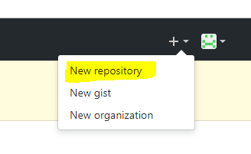

**Step 3: -**

Download portable version of git from the link and install the same

<https://git-scm.com/download/win>

**Step 4: -**

create a folder in your local system like I have the following

D:\GEGDC\SB00557054\GIT\Repository

**Step 5: -**

Open git-bash in your system

**Step 6: -**

so to the path that you created in step 4

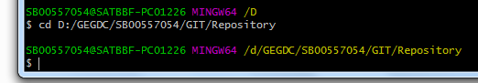

**Step 7: -**

Generate a token in GitHub using the following link. Check all the checkbox while generating

<https://github.build.ge.com/settings/tokens>

copy the token number.

**Step 8: -**

Run the command in Git bash to clone GitHub repository in your local folder.

Git clone [https://<token>@github.build.ge.com/BigDataProjects/IQP.git](https://%3ctoken%3e@github.build.ge.com/BigDataProjects/IQP.git)

After this step you will get a same folder as your repository in your local folder.

**Step 9: -**

change or add the codes that you need to upload or update in GitHub.

**Step 10: -**

In Git bash go to the path of the new folder that got created in step 8.

**Step 11: -**

Command to check Status

git status.

This will show your what are changes done by you.

**Step 12: -**

Now to upload the files in GitHub use the following command

git add .

**Step 13: -**

Commit the files.

git commit –m “<message text>”

**Step 13: -**

To show up the files in GitHub use the command.

git push -u origin master

**now it is ready…**